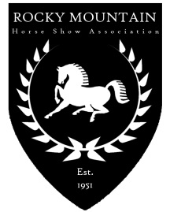

Rocky Mountain Horse Show Association

2023 Membership Application

To qualify for year-end awards, the owner of the horse AND the rider must belong to RMHSA. Note that lessees and co-owners must all belong to RMHSA.

Mr. Mrs. Ms. |  |  |  | Phone:
(circle one) | Last | First | MI

 | Street Address |  | City | State | Zip

E-Mail Address

Check this box ONLY if you do not want your name/contact information included in the Annual Membership Handbook

Type of membership (check one): Individual $30 Juvenile $20

Checks returned for insufficient funds will be charged a $25 fee.
Membership will be effective upon receipt of good funds. POINTS WILL NOT BE RETROACTIVE!

You may return my membership card and communicate via: E-Mail U.S. Mail

Is the juvenile member an academy rider?

Parent or Guardian Signature for Juvenile Members

Juvenile Memberships: Below list the birth date(s) and age(s) of juvenile rider(s) under the age of 18 as of December 1, of the previous year, who may show in equitation, age group classes, or academy classes. Note: Children over the age of 17 must have an INDIVIDUAL membership for points on their horse to count for an award.

Name |  | Birthdate |  | Age

Name |  | Birthdate |  | Age

Name |  | Birthdate |  | Age

Make checks payable to: RMHSA  Mail membership to: RMHSA  5107 Lebsack Lane  Loveland, CO 80537 | For office use only:
 | Received | Check # | Number
 | Referred by:
Rev. 01/2023

